* flow of supply chain
  + from where it came form
  + how procced and where
  + distributed center
  + retails stores
  + customer

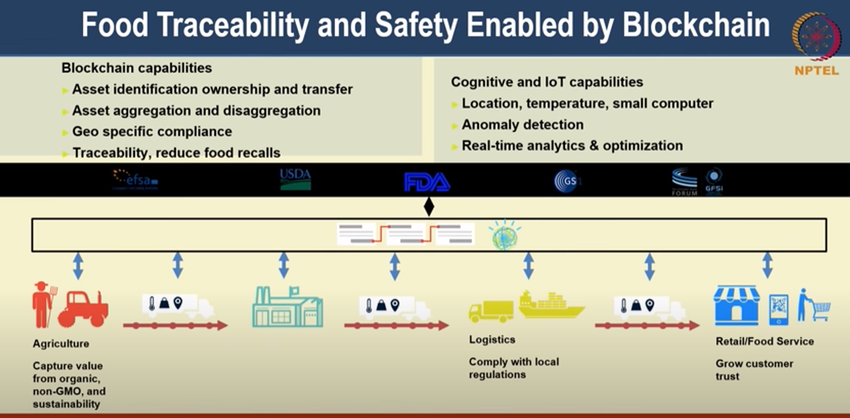

things to record

* Source
* destination
* origin of item
* time
* quality
* location
* functions
* updation of details at points
* payments automatically sent
* users can get track and quality details
* Approch:---
  + add id to main product (food item)
  + add id to each of component and their souces
  + link components to laptop
  + track all these components
  + combine all for full tracking process